This will convince any School!

Delete, Type Print, Sign, Scan and Send to your school and Grab a Trip to Our USA Office

SUBJECT LINE: <Insert Your Principal Name and Complete School Address Here>, I’d like to pray you to involve/ participate/attend NLSR 2023 previously known as CSR 2020

Hi <Insert Your Principal Name Here>,

As you know, keeping up on the latest competition and reputation of school is essential for our school. <You may want to customize this first sentence based on your unique needs>

The folks over at Give Globally Foundation, USA are hosting National Level School Ranking 2023 in India on May 2024.

They expect 4,000 Schools in attendance.

I believe that involving and attending this event will enable our/ your school and its students to network with different schools and student intellectuals and leaders and discover valuable new ways to bring the reputation of our school.

Here’s a quick breakdown of the event:

Top 10 Platinum Schools of the State
Top 10 Gold Schools of the State
Top 10 Silver Schools of the State
Best School of the Country
Top Hundred Schools of the Country

Awards based On Ranking Standard wise (City-Level)

- Top 10 schools Based on student Result at Play School  - Top 10 schools Based on student Result at LKG  - Top 10 schools Based on student Result at UKG  - Top 10 schools Based on student Result at Std. 1  - Top 10 schools Based on student Result at Std. 2  - Top 10 schools Based on student Result at Std. 3  - Top 10 schools Based on student Result at Std. 4  - Top 10 schools Based on student Result at Std. 5 | - Top 10 schools Based on student Result at Std. 6  - Top 10 schools Based on student Result at Std. 7  - Top 10 schools Based on student Result at Std. 8  - Top 10 schools Based on student Result at Std. 9  - Top 10 schools Based on student Result at Std. 10  - Top 10 schools Based on student Result at Std. 11  - Top 10 schools Based on student Result at Std. 12
Please note that the Student result will be calculated based on the data of last three years of a school provided by the school itself.

Activities in the City in collaboration with all the schools.

Dashing talent show of Little Knights (children)
Daring talent Show of Youth Knights (Standard 5th to 12th)
Dashing Talent Show (state level) Little Knights (Children)
Dashing Talent Show (state level) Youth Knights (Standard 5th to 12th)
Dashing talent show (National Level) of Little Knights (children)
Daring talent Show of Youth Knights (Standard 5th to 12th)

Here’s the cost break down:

All the interested Schools must pay one time fees to participate in the program along with the documents. All the participating institution may receive an accreditation Certificate from the internationally repute accreditation organization like IAO and USNews like organisation*. The cost of the Certificate is USD 1500 which will be available to the institution free of cost with many more appreciation from the event CSR 2017 at Local and National Level.

The Fee is as below:

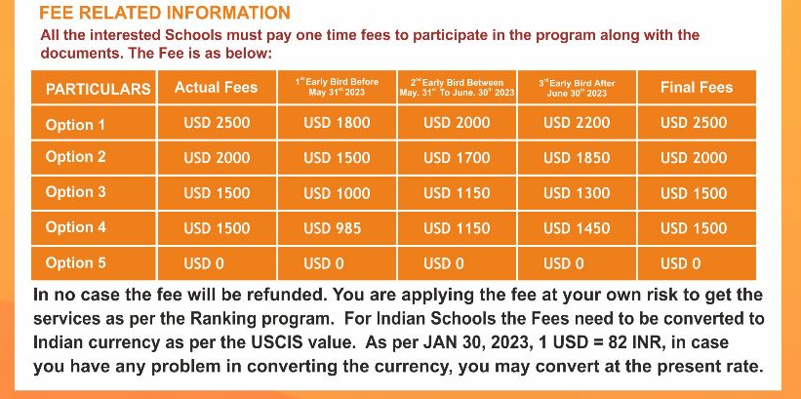

With your permission I’d like to you to secure our/ your School involvement in the program NLSR 2023 and do the reservation to this event before it sells out. Please reply to me or contact the organization as soon as possible with your decision.

Thanks for considering it.

<Insert Your Name / Designation/ Contact number/ Email Here>
On behalf and in support of
www.csr.givegloballyfoundation.org
* This will be provided to only interested schools upon special request and a special fee.

